**Kindergarten**

**Common Core State Standards**

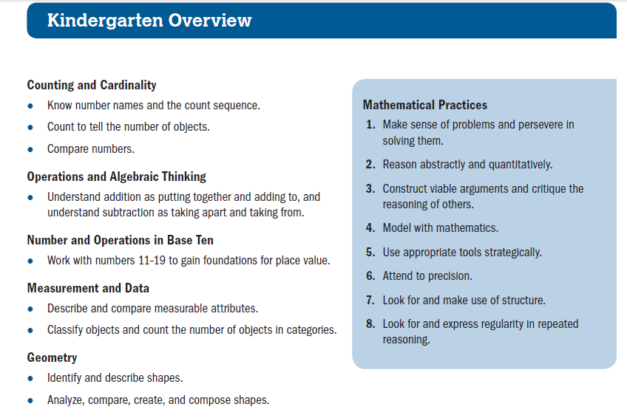

**First Grade**

**Common Core State Standards**

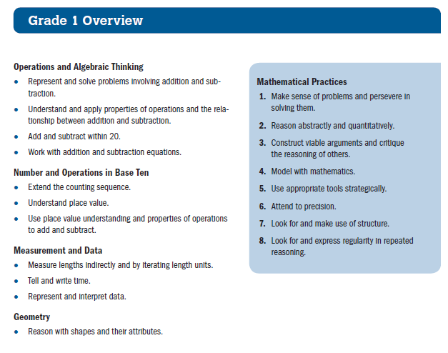

**Second Grade**

**Common Core State Standards**

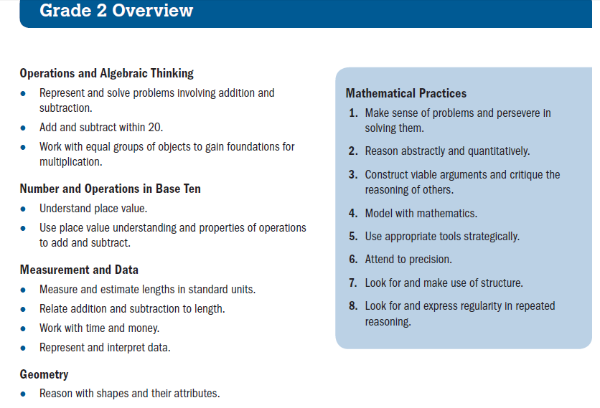

**Third Grade**

**Common Core State Standards**

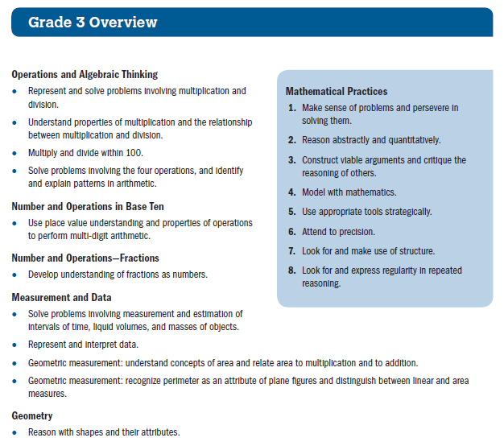

**Fourth Grade**

**Common Core State Standards**

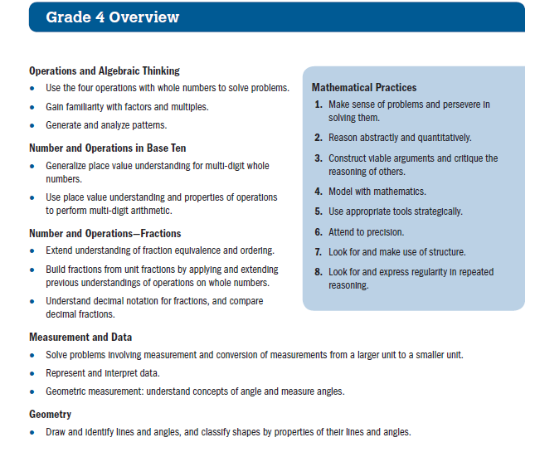

**Fifth Grade**

**Common Core State Standards**

